Abstract
Smart phones or Mobile Phones have become an essential part of our everyday life. Mobile phones play an important role in our life. They are almost used everywhere and by everyone for its different various functions. The technology has advanced so much that with the help of our Mobile phones we can almost do anything. We can contact each other, we can control electrical devices, we can call each other, we can message each other and many more things that we can do with the help of Mobile phones.
We selected this project because we were interested in understanding and knowing about the signals and detection of Mobile. The understanding related to Mobile signals attracted our interest into this project and motivated us to select this for our semester project. We were interested and excited to know how the signals of the Mobile phone can be detected.
We have selected our IC CA3130 which was also easily available in MultiSim. Then we studied and understand the working of this IC with the help of datasheet of this IC and also the pin diagram. This IC consisted of 8 pins (1- 8). This IC is an Op Amp (Operational Amplifier).
After understanding the pin diagram and the functions of pins with the help of datasheet then we made the circuit. We did the connections according to the datasheet of this IC. Then we completed the circuit and tried giving the input.
As MultiSim does not have antenna that would help to detect the Radio Frequencies of the signals emitted. So, in this case we used function generator, which generates waveforms of any frequencies and gives those frequencies as input to the circuit. And the circuit then detects if the radio frequencies are in the range of Mobile signal frequencies, then the circuit will trigger the alarm (LED or Buzzer). If not, then there will be no output.

Figure 1: Block Diagram 2
Figure 2: Detailed Circuit Diagram 2
Figure 3: Truth Table for My Design Combinational Part 3
Figure 4: Simulation 4

Contents
Chapter 1: Introduction 1
- Overview of Project 1
- Block Diagram of Complete System (without using ICs, just use simple blocks) 2
- Clear Work Division 2
Chapter 2: Design 3
- Problem Statement 3
- Truth Table / State Diagram 3
- Complete Logic Diagram 4
- Simulation Results 5
- Schematic Diagram 8
- Details of ICs used 9
  - IC CA3130 9
  - IC LM358(not used) 10
- Details of Other Components used like diodes, transistors, resistors etc. 11
- Simulation Issues / Results/ Observations ..15
Chapter 3: Project Applications /Further Suggestions (Optional) ..16
Chapter 4: Future Recommendations ..17
References / Bibliography ..18

Chapter 1: Introduction

Overview of Project

Now-a-days Mobile phones are used all over the world and by every person of any age. Mobile phones have become an essential part of our life. With the help of advanced technology, mobile phones play an important role in one’s life. They are used to contact from one corner of the world to another corner.
However, there are some places or restricted areas where the use of mobile phone is prohibited. So, to check the maintenance and the rule / restriction we can use a simple device or a circuit which detects the signals of the mobile phones and triggers the alarm when the signal is successfully detected.
The input of the circuit is just the Radio Signals that emits from the mobile phones. If the frequency of this radio signals is within the range of the Mobile Signal Frequencies, then the circuit will do its job.
The output of the circuit is connected to a LED, so whenever the frequency is detected of the range of Mobile Phone Signal then the output of the circuit i.e., LED will glow, and the Buzzer (if connected) will also be activated.
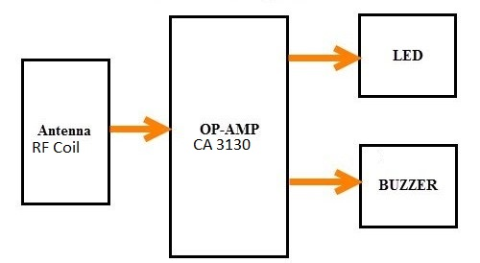
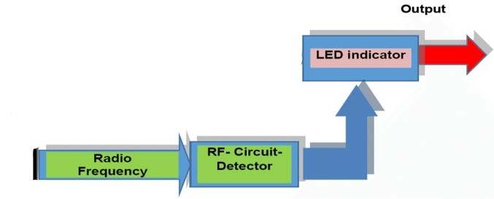

Block Diagram of Complete System (without using ICs, just use simple blocks)

Emission of Radio Frequency

The signals from the mobile phone is emitted and goes to the antenna or RF coil.

Detection of Radio Frequency

The signals that are emitted from mobile then are detected by the antenna or coil of the circuit and thus gives the output.

LED (Output)

If the signals that received are of the frequency of mobile signals, then the LED on the output glows.
Alarm will go on if Buzzer is connected.

Figure 1: Block Diagram

1. Clear Work Division
We divided the work equally among us, so by doing this there was not too much pressure only on one person. We faced some problems but we did solve all it together.

Jameel Furqan
Did work on the Arranged the
components of the details of the
projects. And also components and
did the simulation also did the simulation
and took part in the and helped
project compilation. in project report.

Haseeb
Sequenced the data in the file. Also made the logic diagrams and did the final simulation and arranged the project report.
Figure 2: Work Division

Chapter 2: Design

Problem Statement

Mobile phones are used everywhere and almost by humans of any age. So, there are some places and restricted areas where mobile phones are not allowed to be used.
Thus, in order to detect mobile phones in such areas there arose the need of such device to detect the presence of mobile phones. Such device can be created with the knowledge of digital logic. Then we create an electrical circuit.
This circuit is such created that whenever it receives the signals of frequencies within the range of Mobile Phone Signals then the circuit detects such signals and as a result the LED / Alarm of the circuit triggers and we come to know that there is mobile phone being used in that range.

Truth Table / State Diagram

Function Generator |  | Outputs
Signals Range | Frequency | LED | Buzzer  (if connected)
0.8 to 3 GHz | GigaHertz | Blinks | Active
400 to 900 MHz | MegaHertz | Blinks | Active
1 to 600 kHz | kiloHertz | Slow Signals | -

Function Generator |  | Outputs
Signals Range | Frequency | LED | Buzzer
1 to 18 MHz | MegaHertz | Null | Null
1 to 900 fHz | femtoHertz | Null | Null
1 to 13 µHz | microHertz | Null | Null

Figure 3: Truth Table for My Design Combinational Part

Complete Logic Diagram

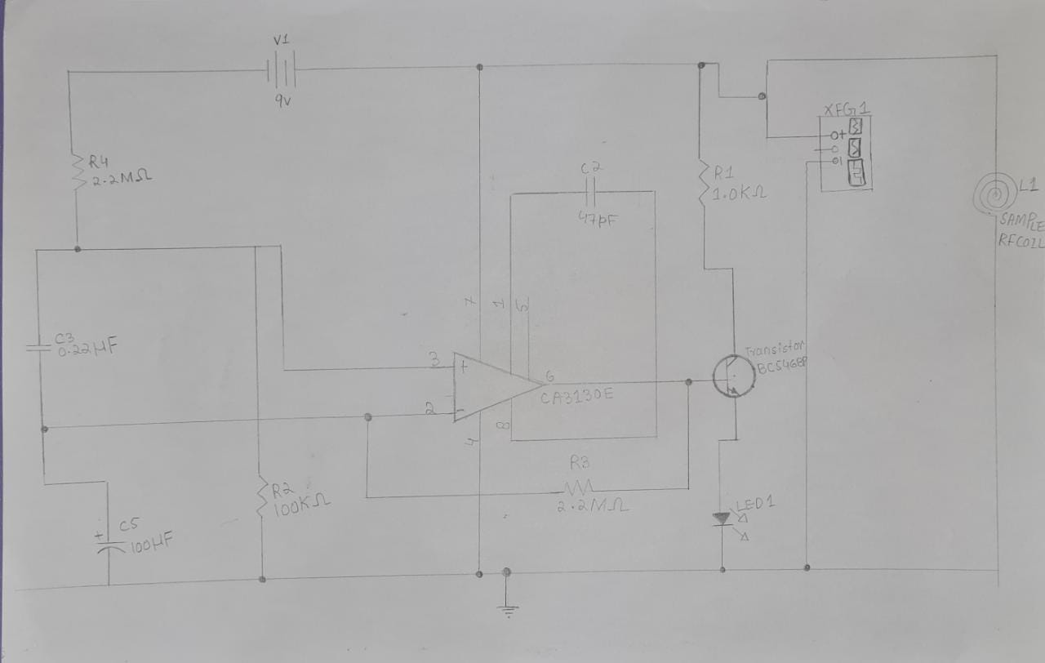

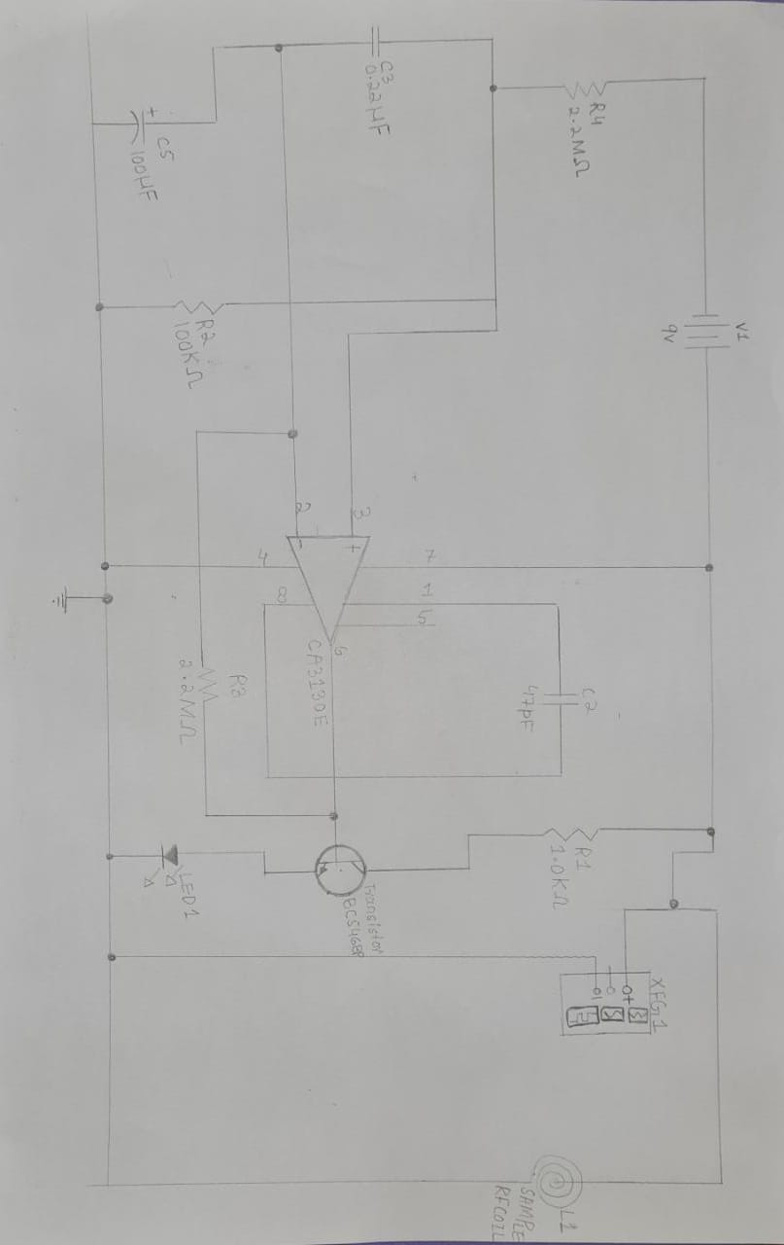

Simulation

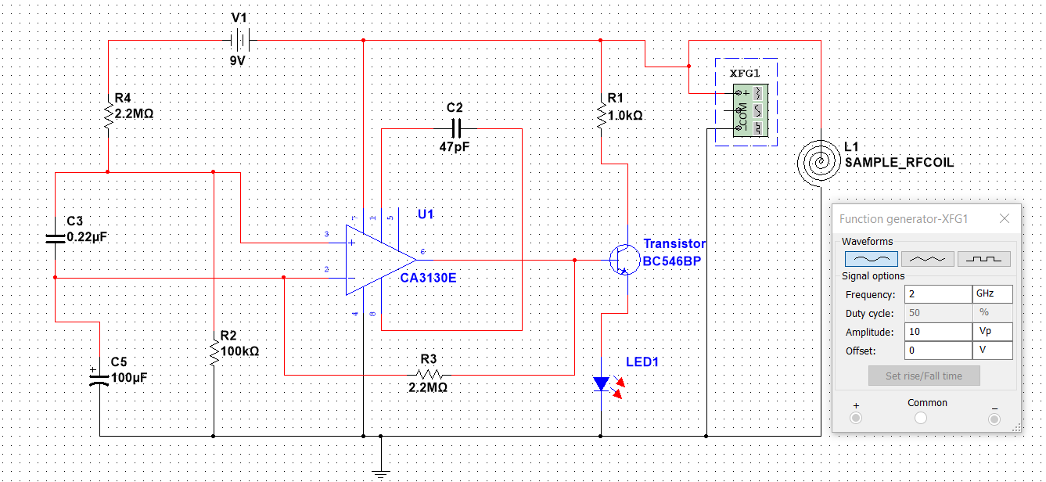

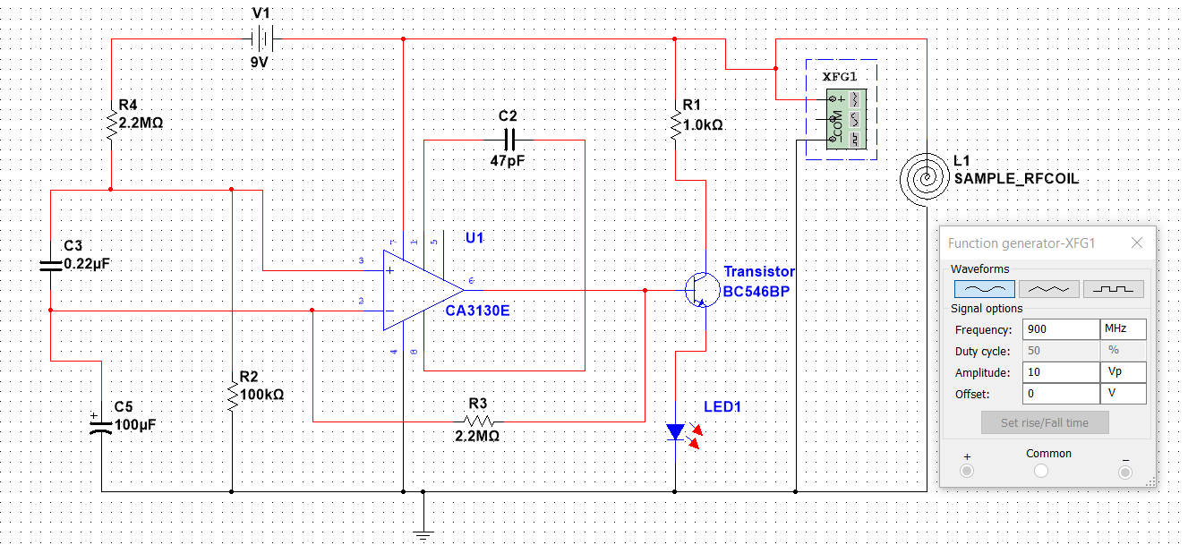

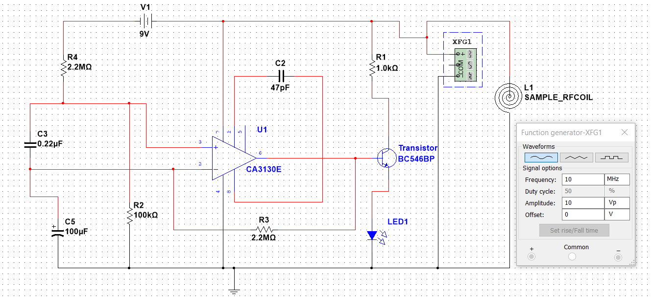

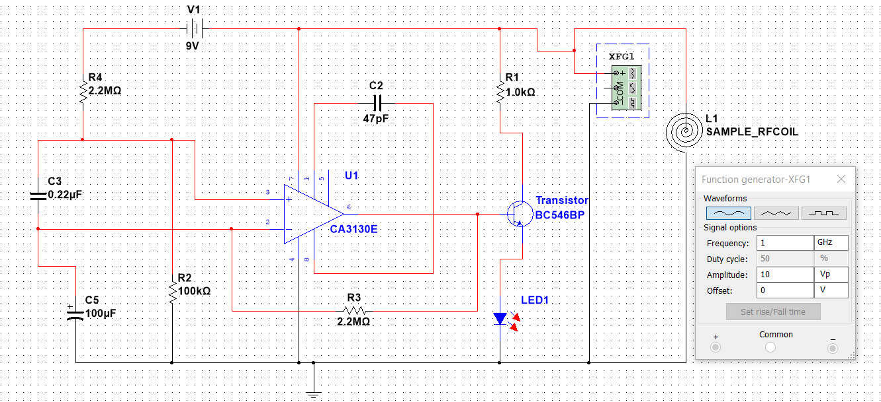

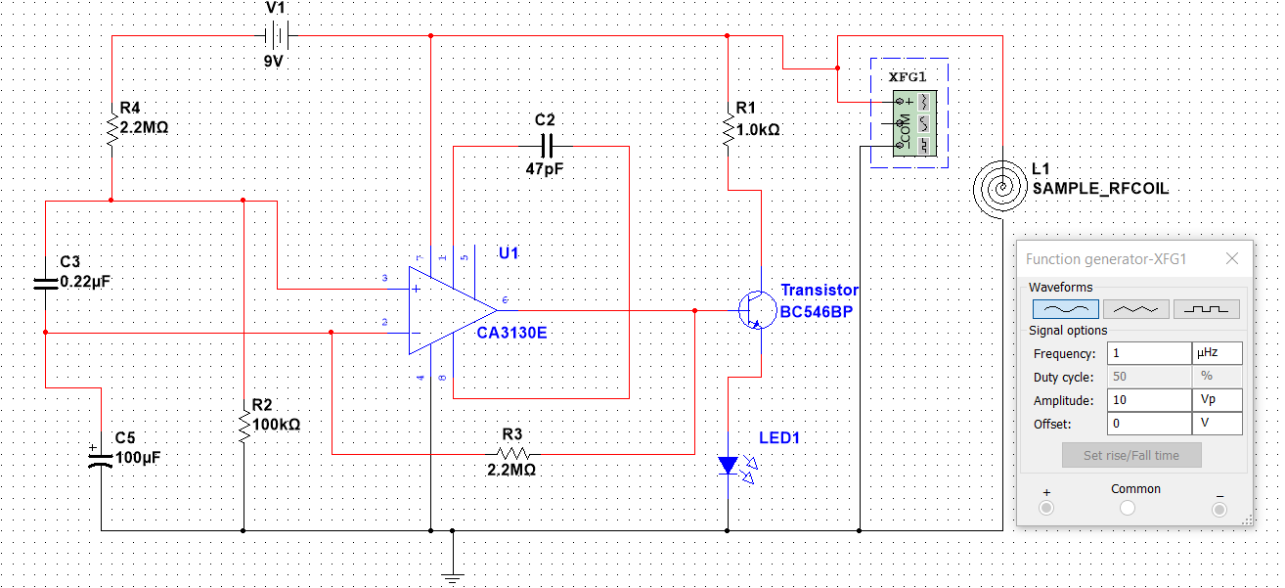

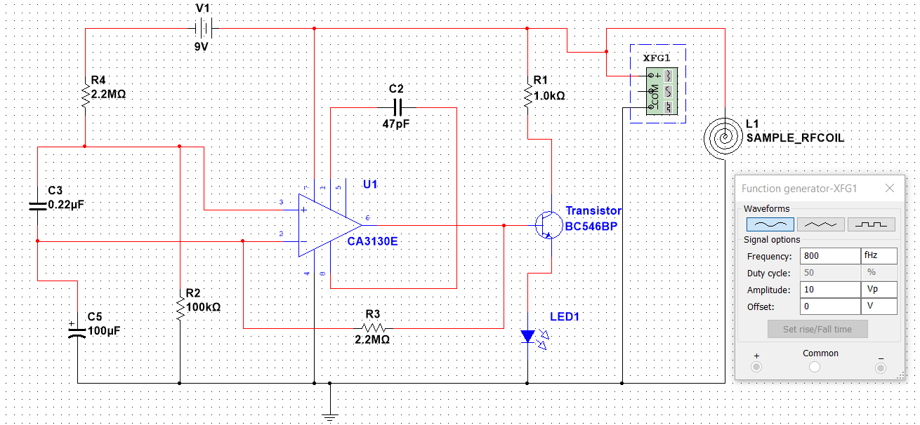

Detailed Schematic of Design and its Description

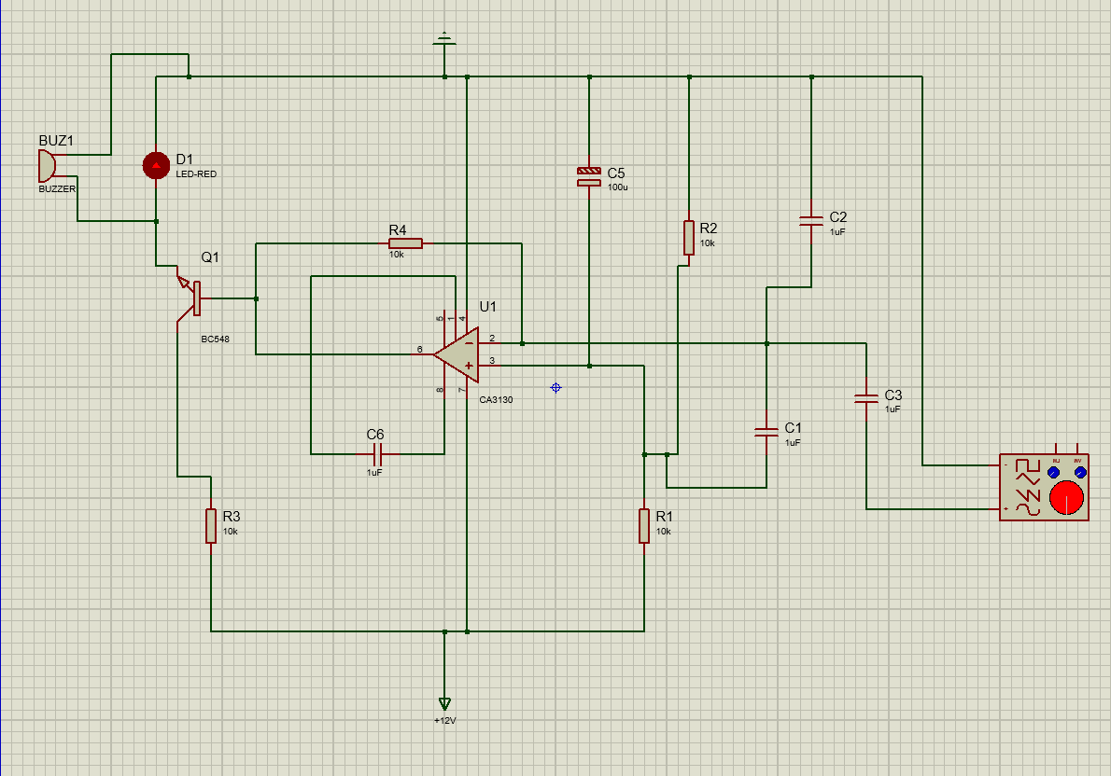

Pins used of CA3130:
Pin 1: Used
Pin 2: Used
Pin 3: Used
Pin 4: Used
Pin 5: Not Used
Pin 6: Used
Pin 7: Used
Pin 8: Used

Serial # | Component | IC Number | Quantity
1 | CA3130 | CA 3130 E | 1
2 | Resistors | - | 4
3 | Capacitors | - | 2-3
4 | Transistor | BC 546 BP | 1
5 | LED | - | 1

Details of ICs used
    - IC CA3130

Function Table

Pin Number | Pin Name | Pin Function
1 | Offset Null | Used to null the offsets between two input terminals
2 | Inverting Input | Inverting input of Op Amp
3 | Non-Inverting Input | Non-Inverting input of Op Amp
4 | GND (V-) | Ground
5 | Offset Null | Used to null the offsets between two input terminals
6 | Output | Output of Op Amp
7 | Vcc (V+) | Supply Voltage
8 | Strobe | Phase Compensation or Shutdown the output stage

Schematic

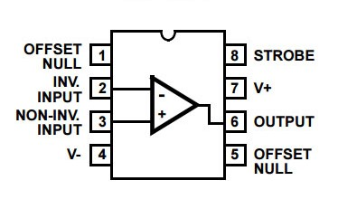

    - IC LM358
(Not available in MultiSim / This IC can also be used)

Function Table
Pin Number | Pin Name | Pin Function
1 | Output A | Output of OPAM A
2 | Inverting Input A | Inverting input of OPAM A
3 | Non-Inverting input A | Non-Inverting input of OPAM A
4 | GND | Ground
5 | Non-inverting input B | Non-Inverting input of OPAM B
6 | Inverting input B | Inverting input of OPAM B
7 | Output B | Output of OPAM B
8 | V+ | Supply Voltage

    - Schematic
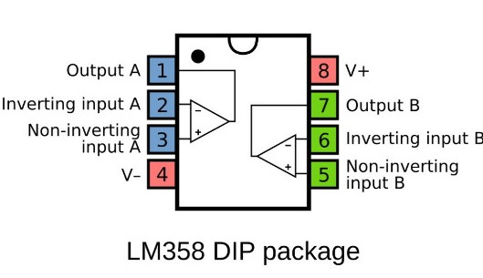

Details of Other Components used like diodes, transistors, resistors etc.

Transistors:
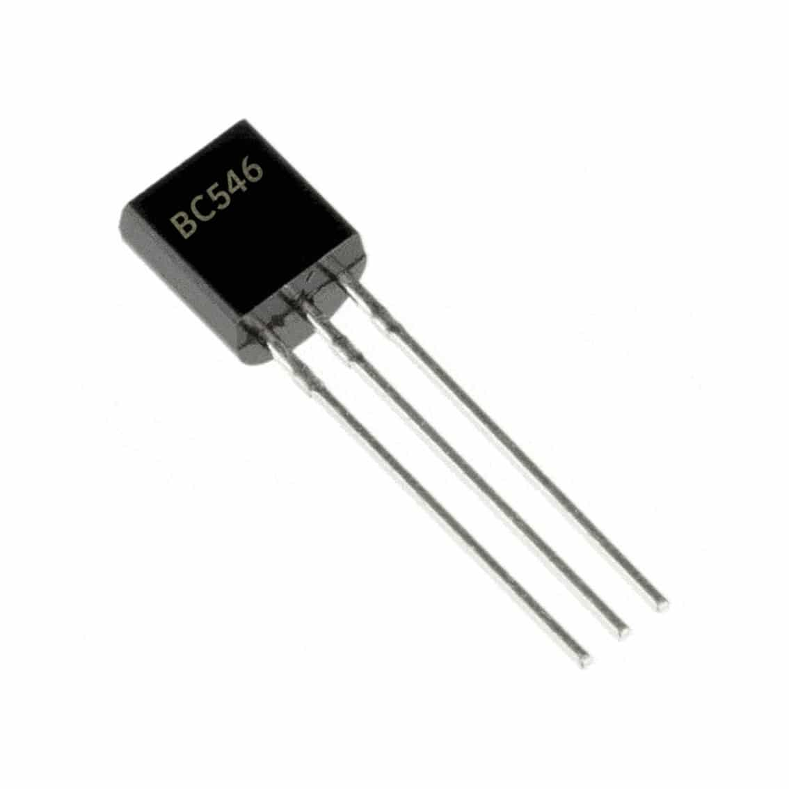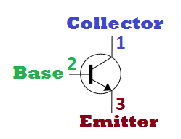
BC546 is an NPN Transistor. A transistor is a semiconductor device used for amplifying, controlling, and generating electrical signals. Transistors are active components of integrated circuits. It is composed of semiconductor material usually with at least three terminals for connection to an external circuit.

Resistors:

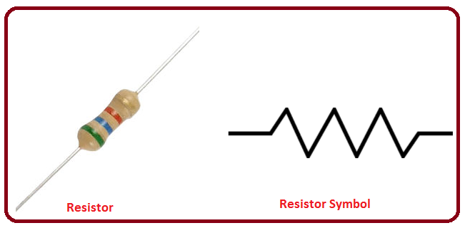

A resistor is an electrical component with the primary function to limit the flow of electric current.
In electronic circuits, function of resistors is to reduce the flow of current, adjustment of signal levels, and to divide voltages so the component is not destroyed.

Capacitors:

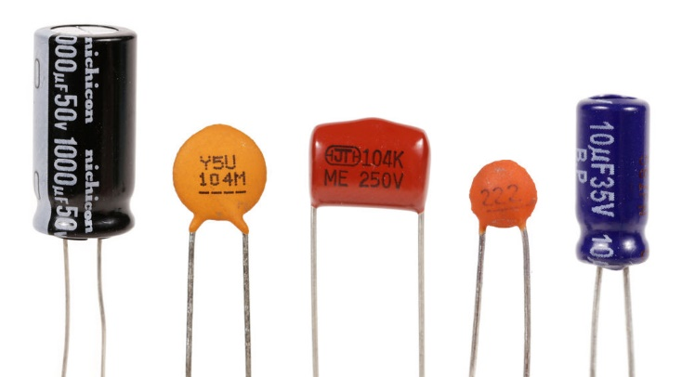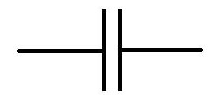

A capacitor is an electronic component that stores the electricity in a circuit. Unlike a resistor the capacitor does not dissipate energy. Instead, a capacitor stores the electrical energy in the form of an electrostatic field between its plate. And it releases the energy when necessary.

RF Coil:

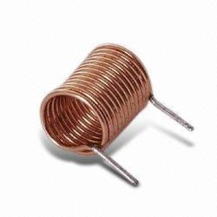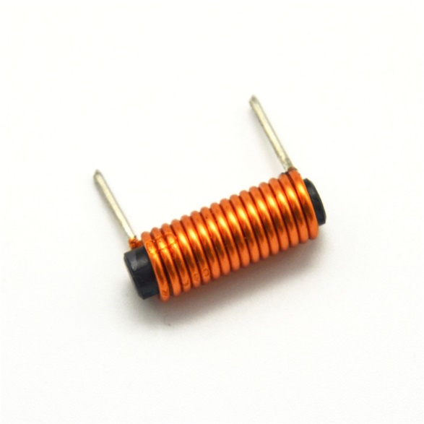

RF coils are known as Radio Frequency Coils.
Radio Frequency Coils (RF coils) consists of two electromagnetic coils, the transmitter and receiver, which generates the field and receive the resulting signals.

LED:

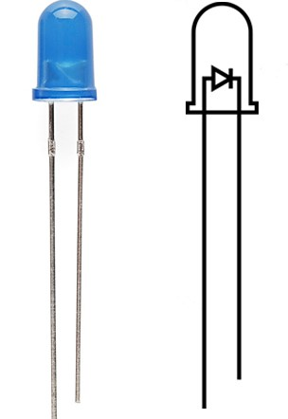

LED is used as an output connected to the circuit. It is connected to the output pin of the circuits to observe the output.
In this circuit it is used for the indication of the presence of mobile phone notification like outgoing and incoming call, sending and receiving the message.

Function Generator:

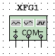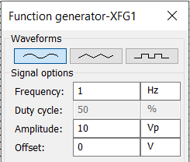

It is used to generate different types and different forms of Waveforms and frequencies.
By the help of Function Generator, we can generate waveforms of required frequencies and check the required output / simulation.

  - Simulation Issues / Results/ Observations

The issue that we faced is the changing of frequency when the simulation is still running. So, in order to run the simulation correctly, first we have to stop the simulation, then change the frequency and run again to see the results.
We observed different result on different frequencies. The LED glows, when the frequency of mobile signal is detected and vice versa.

Chapter 3: Project Applications

Applications of the project is as under:

1.Examinations Halls

This circuit can be used in Examination Halls to check the presence of Mobile Phones. If the frequency of Mobile signals is received at the circuit, then the LED / Alarm of circuit will be activated.

2. Meetings

This circuit can also be used in Meetings. In some meetings where the Mobile phone is prohibited. With the help of this circuit, you can detect the presence of Mobile phone whether the mobile is present or not.

3. Unauthorized transmission of audio or message

It can be used to detect Mobile phone where the mobile is not allowed to be used or is being used secretly as spying. It can be used to catch the secretly ongoing transmission of audio or message.

4. Detection of Mobile Phones

This circuit can be used to detect Mobile Phones which are being used as spying. It can help in detecting the devices where mobile phone is prohibited such as Petrol pumps, Gas station, Historical places, Religious places, and Court of Laws.

Chapter 4: Future Recommendations

- By the addition of Buzzer in the circuit we can use it as alarm. So, whenever a mobile phone signal is detected, the alarm will go on and we will know the presence of mobile phone.
- The application of this circuit is very vast. By the addition of other components this circuit can be useful, such as increasing the area / range of the detection (circuit).

References / Bibliography

- CA3130 Datasheet:
[https://www.theengineeringprojects.com/2020/10/ca3130-mosfet-op-amp-datasheet-pinout-features-applications.html]

- Theoretical background and Website consulted:
[www.electronicshub.org/cell-phone-detector-circuit/]

